**Worldbook Kids on Line Lessons**

**2nd Grade**

|  |
| --- |
| **Instructional Goal:**  To use World Book Kids online to locate information to research two animals of their choice. |

|  |
| --- |
| **Target Population:** Second grade students at Paxton Consolidated Schools. |

|  |  |
| --- | --- |
| **Nebraska Language Arts Standards:** | **Nebraska Science Standards:** |
| LA 2.1.6.e Retell and summarize the main  idea from informational text.  (This std. For later in unit) | SC 2.1.1 d Describe objects, organisms, or  events using pictures, words, and  numbers. (This std. for later in unit) |
| LA 2.1.6 o Respond to text verbally, in writing  and artistically. | SC 2.3.1 a Students will investigate the  Characteristics of living things. |
| LA 2.3.2 b Use information in order to  complete a task (e.g., follow multi-  step directions, responding to  questions). |  |
| LA 2.4.1 a Use resources to answer guiding  questions (e.g., print, electronic) |  |

|  |
| --- |
| **21st Century Standards:** |
| 1.1.1 Following an inquiry based process in seeking knowledge in curricular subjects, and make  the real world connection for using this process in own life. |
| 1.1.6 Read, view and listen for information presented in any format (e.g., textual, visual, media,  digital, in order to make inferences and gather meaning. |
| 1.1.8 Demonstrate mastery of technology tools for assessing information and pursuing inquiry. |
| 2.1.4 Use technology and other information tools to analyze and organize information. |
| 2.4.1 Determine how to act on information (accept, reject, modify). |
| 3.1.6 Use information and technology ethically and responsibly. |
| 4.1.7 Use social networks and information tools to gather and share information. |

|  |  |
| --- | --- |
| **Needs Assessment** | |
| **What Is:**  1. Second grade students are not familiar  with World Book Kids online, or how to  access WBKs on line. They are familiar  with lap-top use (25 min. per week ave.)  2. This year a link for World Book was placed  onto the school home-page, and the  administration would like teachers to  integrate it into their lessons. This is  because 21st Century Skills need to be  integrated into the curriculum.  3. The second grade teacher has not yet  implemented World Book Kids on line  and would like to collaborate to do so. | **What Should Be:**  1. Students will benefit, in their future  studies, and research, by knowing  how to access and use World Book online.  2. All teachers, and the media specialist  would be implementing World Book  on line into instruction for their students,  and the students will be able to access  WBKs on line when doing research on  their own. This would also integrate  the 21st Century Skills into their curriculum.  3. The media specialist and the second  grade teacher will integrate World  Book on line into a science research unit,  and this would have all staff integrating  WBKs into the curriculum, which will offer  our students a good tool for research, and  experience with using an online  encyclopedia. This will be one more step  in helping our students with information  literacy skills for the 21st century. |

|  |  |  |
| --- | --- | --- |
| **Learner Analysis** | | |
| **Learner Analysis**  The learners are fourteen  students in a second grade  regular education  classroom at Paxton  Consolidated School. | **Data Sources**  1. Observation  2. Observation  3. Teacher interview  4. Teacher interview  5. Teacher interview  6. Teacher interview. | **Learner Characteristics**  1. . Students who are  distracted more easily than  the rest: Two.  2. Students with high  abilities: Four  3. Students who have IEPs:  Two  4. Students from a low social  economic category: Four  5. Students with behavioral  disorders: One  6. There are two students  who have low level  learning disabilities and  will need more assistance  throughout the process. |
| Attention Span | Classroom observations | Two of our second grade students become distracted easily, and take apart items, such as mechanical pencils etc… in the classroom. They then ask that the directions be repeated when it is time to do the assignment. The computer laptops will help with this because they provide a tactile instrument for these students, but the laptops will be retrieved after the initial instructions. |
| Motivation Levels | Classroom observation &  Teacher Interviews | The students respond well to a challenge, especially if it is in the form of competition.  There is one student that has significant behavioral challenges and will need assistance to stay on focus.  Students really are motivated when using the laptops, really seem to enjoy this time. |
| Attitudes Towards Learning | Classroom observation &  Student Surveys | One of the fourteen students has a somewhat negative attitude towards learning, or school in general. This may be partially due to previous lack of success in school, or low self confidence level.  All students have a positive attitude toward laptop use for learning, and like to use them because they have used them to play learning games, and go to specific teacher directed web sites.  The students know how to handle the laptops well, and had a positive attitude toward doing so.  However, their time with the  lap-tops is limited to 25 minutes per week. |
| Reading Levels | Reading test scores on state exams (Dibels) administered previous semester (fall). – Source: Teacher Interview | There are a various level of reading levels in second grade with the majority of students (9) scoring in the average range for reading. Four students scored in the upper range, and two students scored in the lower range. |
| General Classroom Subject Performance | Teacher Interview  Teacher information about student records for previous semester. | Generally, an average range performance by most (9) students in reading and science. Two students scored in the lower level range in reading and science. Four students scored higher than average in reading, and science. |

**Goal:** To use World Book Kids on-line to locate information .

**Instructional Analysis**

2.0

Students will demonstrate a basic World Book Kids

search for information on two animals.

1.0

Using a laptop computer students will be able to log onto World Book Kids online.

4.0

Copy sentences onto their information sheets.

5.0

Students will locate citation information

in World Book Kids on-line

and record it onto their

information worksheet.

3.0

Students will read

for relevant information from World Book Kids.

1.1

Operate laptop start up sequence, by pushing power button.

2.1

Locate the World Book Kids search box on the

computer screen.

3.1

Students will read titles and subtitles.

5.1

Students will locate

citation information on bottom left of WBK’s screen.

of screen.

4.1

Students will list

relevant information in

the form of sentences

onto their information

sheet.

1.2

Demonstrate logging on to the laptop computer with their user name and student password.

3.2

Students will read

Paragraphs while

looking for relevant facts.

2.2

Use computer keyboard

to type in their search word into the World Book Kids search box.

box.

5.2

Students will copy the

complete citation

information on to their

information sheet.

1.3

Locate school home page link and click to open.

1.4

Locate World Book icon on

the school home page and click, then click again on World Book Kids to open.

5.0

Subordinate Skills:

* Knowing what a citation is.
* Knowing what an author is.

4.0

Subordinate Skills:

* Able to copy sentences from a source.

3.0

Subordinate Skills:

* Knowing about titles and subtitles and how to use them when reading.

2.0

Subordinate Skills:

* Able to locate letter keys on keyboard

1.0

Subordinate Skills:

* Unplugging laptop from cart.
* Holding laptop carefully with two hands.

**4.0 Entry Level Skills:**

*Following basic

directions.

*Knowing how to copy

information.

**4.0 Entry Level Skills:**

* **Ability to follow directions.**
* **Able to place sentences on correct line on information sheet.**

**3.0 Entry Level Skills:**

*Have a basic second

grade reading level.

*Some experience reading

to answer questions and

locate information.

*Following basic directions.

**2.0 Entry Level Skills:**

*Know alphabet.

.

**1.0 Entry Level Skills:**

*Experience using computer

mouse and laptop finger pad.

*Know their computer

password.

*Following basic directions.

|  |
| --- |
| **Entry Level Skills & Prior Knowledge:**   * These second grade students have used the lap top, and classroom computers on a once per week basis, for 25 minutes, to play educational games, and visit teacher designated web sites, but not for research. * Students have had practice in removing laptops from the cart and carrying them safely to their desks. * Students have logged onto the system, but always with assistance. * Students have experience with the classroom, and library computer mouse. * Students have used the key board before and are somewhat familiar with how it is set up. * Students have some beginning experience reading to answer questions and to locate information. * Students have experience coping sentences from their spelling instruction. |

|  |  |  |
| --- | --- | --- |
| **Further Information** | **Source of Information** | **Performance Sight Information** |
| Learning site | Teacher interview | Learning will take place in the second grade classroom, and the laptop cart will be brought to the front of the room. |
| Social characteristics | Teacher interview | Students will take turns retrieving their laptops, and carefully taking them back to their desks.  Students will be allowed to help each other by answering each-others questions, about the process, during the lesson, but not during teacher instruction time, or assessment time. |
| Tools for learning | Teacher interview & planning | Laptop computers from cart.  Student checklist  Student grading rubric  Student passwords - teacher has a list.  Student information sheet for sentences and citations.  Pencils |
| Teacher Instruction and guidance. | Teacher interviews | These lessons will be taught by both the teacher and the media specialist as a collaborative effort.  There will be one teaching assistant, and one high school student council assistant. All will have a checklist. |

|  |  |
| --- | --- |
| **Performance Objectives to Meet Instructional Goal** | **Steps to Meet Performance Objectives** |
| 1.0  Using a laptop computer, students will be able to log into World Book Kids online. | 1.1 Demonstrate laptop startup sequence by  pushing the power button.  1.2 Demonstrate logging onto the laptop  computer by entering their user name  and password into the boxes on screen  and pressing enter.  1.3 Locate the school home page link on screen  and click on to go into the school home page.  1.4 Locate the World Book icon on the school’s  home page and click to enter, then click on  World Book Kids. |
| **2.0**  Students will demonstrate a basic World Book Kids search for information on two animals of their choice. | 2.1 Locate the World Book Kids search box on  the screen.  2.2 Use the computer keyboard to type in their  search word into the World Book Kids  search box. |
| **3.0**  Students will read for relevant information from World Book Kids and copy sentences  on to their information sheets. | 3.1 Students will read to locate relevant  information.  3.2 Students will copy full sentences from  WBKs onto their information sheet. |
| **4.0**  Students will locate citation information from World Book Kids on-line and copy it onto  their information sheet. | 4.1 Students will locate citation information on  the bottom left of the screen.  4.2 Students will copy the complete citation  Information onto their information work-  Sheet. |

|  |  |
| --- | --- |
| **Performance Objective Steps** | **Assessments** |
| 1.1 Demonstrate laptop startup sequence by  pushing the power button.  (Care and laptop handling is assessed on an  ongoing basis). | 1.1 A teacher checklist will be used to evaluate  that each student pushes their power button  to turn the computer on.  Student self-assessment check list    Grading rubric.  Post-test activity. |
| 1.2 Demonstrate logging onto the laptop  computer by entering their user name  and password into the boxes on screen  and pressing enter. | 1.2 A teacher checklist will be used to evaluate  when each student has reached the school  home page.  Student self-assessment check list    Grading rubric.  Post-test activity. |
| 1.3 Locate the school home page link on screen  and click on to go into the school home page. | 1.3 A teacher checklist will be used to evaluate  the student entering their password into the  World Book.  Student self-assessment check list    Grading rubric.  Post-test activity. |
| 1.4 Locate the World Book icon on the school’s  home page and click to enter, then click on  World Book Kids. | 1.4 A teacher checklist will be used to evaluate  when each student reaches the World Book  Kid’s icon on the World Book home page.  Student self-assessment check list    Grading rubric.  Post-test activity. |
| 2.1 Locate the World Book Kids search box on  the screen. | 2.1 A teacher checklist will be used to evaluate  that each student has located the WBK’s  search box.  Student self-assessment check list    Grading rubric.  Post-test activity. |
| 2.2 Use the computer keyboard to type in their  search word into the World Book Kids  search box. | 2.2 A teacher checklist will be used to evaluate  that each student has entered their search  word correctly.  Student self-assessment check list    Grading rubric.  Post-test activity. |
| 3.1 Students will read to locate relevant  information. | 3.1 The completed student information sheets will  be evaluated to see if the student was  successful in locating relevant information.  Student self-assessment check list    Grading rubric.  Post-test activity. |
| 3.2 Students will copy full sentences from  WBKs onto their information sheet. | 3.2 The completed student information sheets  will be evaluated to see if the student was  successful in copying full sentences onto their  information sheet.  Student self-assessment check list    Grading rubric.  Post-test activity. |
| 4.1 Students will locate citation information on  the bottom left of the screen. | 4.1 The completed student information sheets  will be evaluated for the level of student  success in locating, and copying, the WBK’s  citation information.  Student self-assessment check list    Grading rubric.  Post-test activity. |
| 4.2 Students will copy the complete citation  Information onto their information work-  Sheet. | 4.2 The completed student information sheets  will be evaluated for the level of student  success in locating, and copying, the WBK’s  citation information.  Student self-assessment check list    Grading rubric.  Post-test activity. |

During the lessons and the post-test assessment the teacher, the media specialist, teaching assistant, and hight student student council aide will have matching checklists. They will use their checklist to assess pre-assigned students during the assessment. The media specialist and the teacher will evaluate the completed information sheets for assessment.

**Collaborative Lesson Plans - 2nd Grade**

**World Book Kids Animal Research**

**Teachers: Lori Applegate – Media Specialist Date: 09-16-2012**

**Content area: Language Arts and Science**

**Title: Animal Research - World Book Kids On-line**

**Grade Level: 2nd Grade**

**Rationale: Having research skills in World Book Kids On-line will benefit students because as a good beginning in the development of information literacy skills for the future.**

**The integration of 21st Century Skills into student curriculum.**

**State Standards:**

**LA 2.1.6 b Use information in order to complete a task (e.g., follow multi-step directions, responding to questions).**

**LA 2.4.1 a Use resources to answer guiding questions (e.g. print, electronic).**

**LA 2.1.6 e Retell and summarize the main idea from informational text.**

**SC 2.3.1 a Students will investigate the characteristics of living things.**

**21st Century Standards**

**1.1.6 Read, view, and listen for information presented in any format (e.g., textual, digital, visual, media, digital, in order to make inferences and gather meaning.**

**1.1.8 Demonstrating a mastery of technology tools for assessing information and pursuing inquiry.**

**2.1.4 Use technology and other information tools to analyze and organize information.**

**2.4.1 Determine how to act on information (accept, reject, modify).**

**3.1.6 Use information and technology ethically and responsibly.**

**4.1.7. Use social networks and information tools to gather and share information.**

**Prior Knowledge and Skills:**

* **Our second grade students have experience using the lap top, and classroom computers once per week for 25 minutes. They play educational games, and visit teacher designated web sites, but have not used the computers not for individual research.**
* **Removing laptops from the cart and carrying them safely to their desks has been practiced with their computer usage each week.**
* **Students have needed assistance to log onto the system and get to the school homepage.**
* **Students are experienced with using the computer mouse.**
* **Students have some experience using the key board, and are somewhat familiar with the letter key set up.**
* **Students have only beginning experience with reading for information or to answer questions from non-fictional sources.**
* **Students have experience coping sentences but not with copying citation information.**

**Goals**

1. **For students to learn through their own discovery, during their research, about animals and their habitats.**
2. **For students to gain practice in locating citation and documenting citation information from research sources.**
3. **For students learn to use World Book Kids on-line to locate information.**

**Objectives:**

**Objective 1: The students will be able to use a laptop computer to log into World Book Kids On-line.**

**Objective 2: The students will demonstrate a basic World Book Kids search for information on two animals of their choice.**

**Objective 3: The students will read for relevant information from World Book Kids.**

**Objective 4: The students will locate citation information in World Book Kids On- line.**

**Objective 5: The students will copy relevant information from World Book Kids onto their information sheets.**

**Materials and Equipment:**

**Introductory lesson 1 materials:**

* **Lesson Plan**
* **Interactive whiteboard**
* **Teacher laptop**
* **Student Animal Research - World Book Kids handout**
  + **Box with animal pictures**
  + **Laptop cart –fully charged**
  + **Blank information sheet lines drawn onto the dry erase board for interactive whiteboard demonstration. (For citation information.)**
  + **Animal encyclopedias**
  + **Pencils**
  + **Student Research Folders Containing:**
  + **Student computer vocabulary lists**
  + **Student Sheet: Animal Research World Book Kids Checklist**
  + **Animal vocabulary sheets from science**

**PREREQUISITE EXPERIENCE:**

**This lesson will be used at the end the science unit - The needs of living things and animal habitats. Students at this time will have read about the habitats of many different animals. Students will have a good basic understanding of each type of animal habitat.**

**Students have used the laptops and will be familiar with many of the computer terms listed on their computer sheets in their research folders.**

**Accommodations:**

**We have two students that have IEP’s. These students will be given extra guidance from our two high school student council assistants, and higher level learning students that will be seated next to them for guidance.**

**Enrichment:**

**These students will be allowed to come up with more research answers, and will be given the extra enrichment activity option of researching a third animal of their choice.**

**Important Vocabulary Words**

**Animal encyclopedias will be on the back counter for students to retrieve throughout the week before this lesson. This will be done to help students decide which two animals they will research. The classroom teacher will have a list of the animals that each student will research. She will have an index card for each student with their animals listed for them on the day of the lesson. (The animals listed on the cards will be changed if the student has decided on different animals to research.)**

**The student’s computer vocabulary word sheet is included in this unit, and will be in the student research folders for students to continue to use when we are using the computers in our lessons**

**Animal Research – Unit Introductory Lesson 1:**

**Anticipatory Set/Motivation:**

**Introduction:**

**In this lesson, each student will choose two animals (There will be four animal encyclopedias available the previous week on the back counter for students to find two animals to research). Students will research their animals to learn about them and the habitats that they live in.**

**Question: Who remembers the different habitats from science?**

**(desert, tundra, rainforest, forest, ocean)**

**Question: Who can name one habitat, and one animal that would live there?**

**At this time write the five habitats on the board – (desert, tundra, rainforest, forest, ocean.**

**Animal Box Activity:**

**At this time bring out the box with all the animal pictures in it and ask 3 - 4 various students, one at a time, to draw an animal card from the box.**

**Question: What animal is on your card?**

**Have them hold up their card when they answer their question.**

**Question: What habitat do you think that animal lives in?**

**Question: Name one way in which you think the habitat may meet the animal’s needs for (air, water, food, shelter)?**

**Today we are going to research our two animals on World Book Kids. First, we will show you what to do on the white board and have each of you follow along using the World-Book Kids Animal Research Direction Sheet.**

**Instructional Activities:**

**Inform Students of Objectives:**

**We will provide a sheet with the objectives, along with the student rubric which is an assessment of the objectives, and we will go over them. The rubric and objective sheets will already be in their animal research folders which will be handed out at this time.**

**Objective 1: The students will be able to use a laptop computer to log into World Book On-line.**

**Objective 2: The students will demonstrate a basic World Book Kids search for information on two animals of their choice.**

**Objective 3: The students will read for relevant information from World Book Kids.**

**Objective 4: The students will locate citation information in World Book Kids On- line.**

**Objective 5: The students will copy relevant information from World Book Kids onto their information sheets.**

**Terminology Sheets:**

**At this time the media specialist will go over computer vocabulary sheet, and ask if the students know which animals they would like to research. The teacher will have a list of the animals that the students have requested to study. The students will have their animals written on an index card. (Again, the animals on the card can be changed if the students have decided on different animals for their research.)**

**Rubric and Student Performance Objective Checklists:**

**The media specialist will go over the student rubric, and the self-assessment checklist**

**and explain how we will use them.**

**Demonstration/Modeling:**

**Using the interactive whiteboard the media specialist will demonstrate the steps while students follow along with their “Student Animal Research – World Book Kids Handout” sheets:**

1. **Logging onto the laptop.**
2. **Locating and clicking onto the homepage icon.**
3. **Locating and clicking on the World Book icon on the school homepage.**
4. **Locating the World Book Kids icon on the World Book page and clicking.**
5. **Locating the World Book Kids search box on the WBKs page.**
6. **Question: Ask students- Who can give me the name of an animal to type into this search box?**
7. **Type the animal name into the search-box and click.**
8. **Point out the titles, and sub-titles as reading the first and second paragraph.**
9. **Ask students to raise their hand when we read a relevant piece of information about the animal, or habitat that is important. Then demonstrate writing the sentence on the board on the pre-drawn information sheet page. (Make sure to hold up the information sheet for comparison.)**
10. **Question: Why is it important to write your references (citations) for the information that you use from the WBKs research?**
11. **Question: Can anyone tell me where the reference (citation) information is on the screen?**
12. **Go down to the left-hand corner of the screen and point out the reference information. (Have a student come point this out.)**
13. **Have a student demonstrate writing it on the board, show them the citation line to write it on.**

**Guided Instruction:**

**The media specialist will go through steps 1- 7 below slowly, on the interactive white board. Before the demonstration the media specialist will introduce the “World-Book Kids Animal Research Direction Sheet” to the students. The students will go and retrieve their laptops and follow the steps on the “ World Book Kids Animal Research Handout sheets.” The second grade teacher, the teaching assistant, and our two high school student council helpers, will also help guide the students through each step, but they will all have been briefed to let the students determine the information that is important. We will want to keep the student in control of their own research. The first copy of the objective assessment checklists will be used to note the student’s progress.**

1. **Students will retrieve their laptops from the cart two at a time.**
2. **Logging-on the laptop.**
3. **Locating and clicking on the home-page icon.**
4. **Using the Animal Research - World Book Kids Guide sheet thBife students will locate and click on the World Book icon on the school homepage, and continue with steps 5 through 7 that follow.**
5. **Locating the World Book Kids icon on the World Book page and click.**
6. **Locating the World Book Kids search box on the WBKs page.**
7. **The students will type their animal into the search-box and click.**

**Independent Practice:**

**Students now will be asked to use their performance objective checklists for the next five steps. (During this time the students will need extra guidance to halp students follow the steps.**

1. **Students will be given time to read for information on each of their two chosen animals.**
2. **When they find information that they consider relevant, they will copy the sentences onto their information sheet.**
3. **Students will copy reference information, from the bottom left-hand corner of the screen, on their information sheets for each sentence that they copy.**
4. **The students will go up two at a time and place the laptops back into the cart and then plug them in.**

**Closure:**

**At the end of the lesson explain to the students that during this week we will have two more times on the computers to continue our animal research on World Book Kids. Also, during centers, and during library time, we will allow students to use the computers in the back of the classroom to continue their research.**

**Also, let the students know about the animal research cube project that we will complete when we are finished with our research.**

**Assessment:**

**During the introductory lesson, and unit the following assessment items will be utilized:**

* **A teacher checklist with the lesson performance objectives.**
* **A student sheet: Animal Research - World Book Kids Checklist.**
* **A grading rubric for student self-assessment, and teaching assessment.**

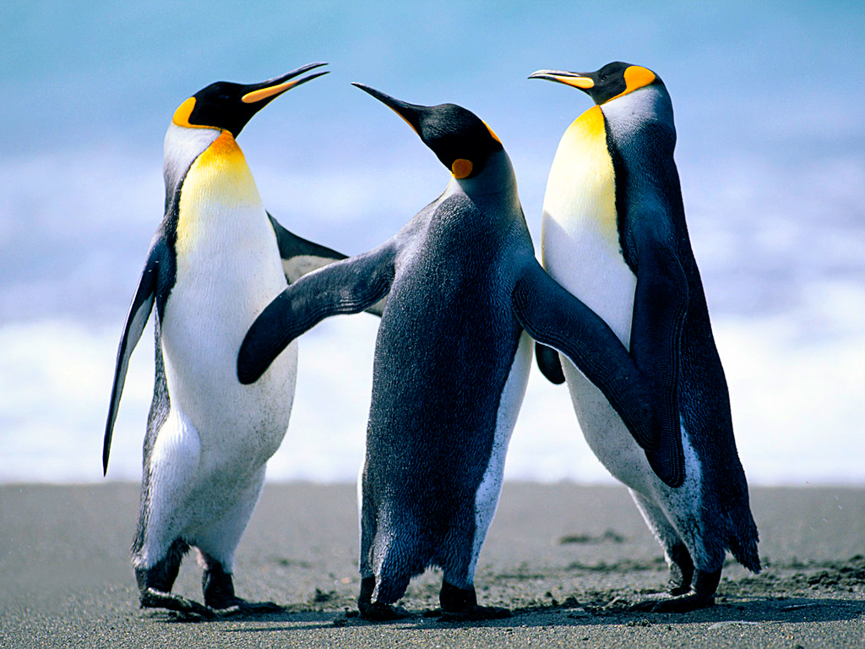

**Animal Research - World Book Kids Objectives – 2nd Grade**

**1 Use your laptop computer to log into World Book Kids.**

**2 Search World Book Kids to find information on two animals of your choice.**

**3 Reading for relevant/important information from World Book Kids On-line.**

**4 Locate reference/citation information in World Book Kids On-line.**

**5 Copy important information from World Book Kids onto your information sheets**

**Animal Vocabulary Words**

**Chapter 2 - Animals   
  
1. mammals-- animals with hair or fur the breathe with body parts called lungs   
  
2. reptiles-- animals with dry, scaly skin   
  
3. amphibians-- animals that start their lives in the water   
  
4. predator-- an animal that hunts another animal for food   
  
5. prey-- an animal that is being hunted   
  
6. food chain-- the order in which living things need each other for food   
  
7. shelter-- a place where an animal can live and be safe   
  
8. larva-- the stage in the life cycle of a butterfly when the insect is a caterpillar   
  
9. pupa-- the stage in the life cycle of a butterfly when a caterpillar spins a cocoon around itself   
  
Chapter 3 - Land Habitats   
  
1. habitat-- a place where plants and animals live and grow and can meet their needs   
  
2. woodland forest -- a habitat that gets enough rain and sunlight for trees to grow well   
  
3. migrate-- to move from one place to another   
  
4. rain forest-- a habitat that gets rain almost every day   
  
5. desert-- a dry, hot habitat that gets very little rain   
  
6. Arctic-- a very cold habitat near the north pole**

**Chapter 4 - Water Habitats   
  
1. pond-- a fresh water habitat in which the water stays in one place   
  
2. stream-- a fresh water habitat with moving water   
  
3. ocean-- a large, deep body of salt water   
  
4. food web- a group of several food chains that are connected   
  
5. pollution-- waste that harms land, water, or air   
  
6. recycle-- use waste to make new things that can be used again**

**Source: Mrs. Cole’s Second Grade Class at Cluster Springs Elementary in Alton, VA**

[**https://sites.google.com/a/halifax.k12.va.us/mrs-coles-second-grade/science-vocabulary**](https://sites.google.com/a/halifax.k12.va.us/mrs-coles-second-grade/science-vocabulary)

**More Vocabulary Words:**

**amphibian -- An animal that begins life in the water and moves onto land as an adult**

**bird – An animal that has feathers, two legs, and wings.**

**carnivore - An animal that eats other animals.**

**fish – An animal that lives its whole life in water and breathes with gills.**

**fresh water – Water that has very little salt in it.**

**gills - A body part found in fish and young amphibians that takes in oxygen from the**

**water**

**herbivore – An animal that eats plants.**

**hibernate - To enter a deep sleep in which life activities slow down.**

**inherit - To receive traits from parents**

**instinct - A behavior an animal knows how to do without being taught.**

**Interact - When plants and animals affect one another or the environment to meet their**

**needs**

**mimicry - An animal's imitation of another animal or of an object in order to avoid predator.**

**omnivore – an animal that eats both plants and other animals.**

**population - A group of the same kind of living thing that all live in one place at the same time.**

**predator – An animal that hunts another animal for food.**

**prey – An animal that is hunted by a predator.**

**reptile – A land animal that has dry skin and is covered by scales.**

**scales - The small, thin, flat plates that help protect the bodies of fish and reptiles.**

**species - A name that identifies a specific kind of organism.**

**threatened - On the way to becoming endangered or extinct.**

**trait - A body feature that an animal inherits; it can also be some things that an animal does.**

**Source: HMS School Publishers Multimedia Science Glossary**

[**http://www.harcourtschool.com/glossary/science/index3.htm****l**](http://www.harcourtschool.com/glossary/science/index3.html)

**Animal Research -World Book Kids Rubric**

|  |  |  |  |  |
| --- | --- | --- | --- | --- |
| **CATEGORY** | **Basic**  **4: Needs**  **Lots of Help** | **Proficient**  **3: Needs a Little**  **Help** | **Good**  **2: Needs Very**  **Little Help** | **Advanced**  **1: Needs No**  **Help** |
| **Computer Log On & Opening World Book Kids** | **1. Handling laptop**  **carefully.**  **2. Push laptop start-**  **up button.**  **3. Log on to laptop. 4. Open World Book**  **Kids.** | **1.Handling laptop**  **carefully.**  **2. Push laptop start-**  **up button.**  **3. Log on to laptop. 4. Open World Book**  **Kids.** | **1. Handle laptop with**  **care.**  **2. Push laptop start-**  **up button.**  **3. Log on to laptop. 4. Open World Book**  **Kids.** | **1. Handle laptop with**  **care.**  **2. Push laptop start-**  **up button.**  **3. Log on to laptop. 4. Open World Book**  **Kids.** |
| **Search World Book Kids for information/Two animals.** | **1. Locate the World**  **Book Search Box**  **on screen.**  **2. Use keyboard to**  **type in search**  **word into search**  **box.** | **1. Locate the World**  **Book Search Box**  **on screen.**  **2. Use keyboard to**  **type in search**  **word into search**  **box.** | **1. Locate the World**  **Book Search Box**  **on screen.**  **2. Use keyboard to**  **type in search**  **word into search**  **box.** | **1. Locate the World**  **Book Search Box**  **on screen.**  **2. Use keyboard to**  **type in search**  **word into search**  **box.** |
| **Read World Book Kids for Information** | **1. Read headings**  **and sub-**  **headings.**  **2. Reading for**  **information.**  **3. Copy complete**  **sentences.** | **1. Read headings**  **and sub-**  **headings.**  **2. Reading for**  **information.**  **3. Copy complete**  **sentences.** | **1. Read headings**  **and sub-**  **headings.**  **2. Reading for**  **information.**  **3. Copy complete**  **sentences.** | **1. Read headings**  **and sub-**  **headings.**  **2. Reading for**  **information.**  **3. Copy complete**  **sentences.** |
| **Locating and Copying Citations** | **1. Locate citation**  **information on the**  **WBKs screen.**  **2. Copy all of citation**  **from WBKs onto**  **information sheet.** | **1. Locate citation**  **information on the**  **WBKs screen.**  **2. Copy all of citation**  **from WBKs onto**  **information sheet.** | **1. Locate citation**  **information on the**  **WBKs screen.**  **2. Copy all of citation**  **from WBKs onto**  **information sheet.** | **1. Locate citation**  **information on the**  **WBKs screen.**  **2. Copy all of citation**  **from WBKs onto**  **information sheet.** |

|  |  |  |
| --- | --- | --- |
|  | | |
| **Animal Research – World Book Kids**  **Student Research Checklist**  **Name:______________________________________** | | |
|  | **1.0** | **Log on to laptop / Open World Book Kids.** |
|  | **Always** | **Handle laptop with care.** |
|  | **1.1** | **Laptop startup sequence (Pushing the power button.)** |
|  | **1.2** | **Log on to laptop (User name and password)** |
|  | **1.3** | **Locate school home page.** |
|  | **1.4** | **Locate World Book icon on school home page. (Enter to open.)** |
|  | **2.0** | **Rearch for information on 2 animals using World Book Kids.** |
|  | **2.1** | **Locate the “search box” on the World Book Kids page.** |
|  | **2.2** | **Type search word into WBK’s search box and press enter.** |
|  | **3.0** | **Read for important information for your research in WBKs.** |
|  | **3.1** | **Read titles and sub-titles when reading for information.** |
|  | **3.2** | **Read the paragraphs looking for information.** |
|  | **4.0** | **Copy sentences onto your information sheets.** |
|  | **4.1** | **Copy the important information sentences onto your sheet.** |
|  | **5.0** | **Locate citation/reference information and write it on your information sheet.** |
|  | **5.1** | **Locate citation information on the bottom left of screen.** |
|  | **5.2** | **Write citation information on to your “information sheet.”** |

**Name_________________________________________**

**Student Information Sheet – Animal Research WBKs**

**Place your research sentences on the lines that are numbered. Write your citation information, on the line below your sentence marked citation. (Remember: You will find the citation on the lower left area on the World Book Kids Screen.)**

**Animal I am researching:**

**Sentence 1:__________________________________________**

**____________________________________________________**

**____________________________________________________**

**Citation: ____________________________________________**

**___________________________________________________**

**___________________________________________________**

**Sentence 2: __________________________________________**

**____________________________________________________**

**____________________________________________________**

**Citation_____________________________________________**

**____________________________________________________**

**____________________________________________________**

**Sentence 3: __________________________________________**

**____________________________________________________**

**____________________________________________________**

**Citation_____________________________________________**

**____________________________________________________**

**____________________________________________________**

**Sentence 4: __________________________________________**

**____________________________________________________**

**____________________________________________________**

**Citation_____________________________________________**

**____________________________________________________**

**____________________________________________________**

**Sentence 5: __________________________________________**

**____________________________________________________**

**____________________________________________________**

**Citation_____________________________________________**

**____________________________________________________**

**____________________________________________________**

**Sentence 6: __________________________________________**

**____________________________________________________**

**____________________________________________________**

**Citation_____________________________________________**

**____________________________________________________**

**____________________________________________________**

**Student Animal Research - World Book Kids On-line Handout**

1. **Logging onto the laptop.**

**To start up the laptop push the button on the top of the keyboard and wait.**



**______________________________________________________________________**

**2. Type your “user name,” and “password,” and “enter.”**

1. **Locating and clicking onto the homepage icon.**

**Click on the word “home” in the upper left hand corner of the screen.**

1. **Locating and clicking on the World Book icon on the school homepage and enter..**

* **Additional Links**
  + [**Accelerated Reader**](https://hosted11.renlearn.com/206451/Public/RPM/Login/StudentLogin.aspx)
  + [**Concessions**](http://athena.esu16.org/~jluedke/Concessions/Schedule.html)
  + [**Cross Country**](http://athena.esu16.org/~ksterr/Website/Welcome.html)
  + [**eFunds**](https://eps.mvpbanking.com/cgi-bin/efs/login.pl?access=55366)
  + [**ESU 16 Email**](https://secure.project42.k12.ne.us/SOGo/)
  + [**Future Problem Solvers**](http://athena.esu16.org/~tmaunder/Paxton_FPS/Home.html)
  + [**Gaggle**](https://www.gaggle.net/gen?_template=/templates/gaggle/html/index.jsp&cdnSupported=true)
  + [**IXL**](http://www.ixl.com)
  + [**Livestream Events**](http://www.livestream.com/paxtonschools/)
  + [**Lunch survey**](http://www.surveymonkey.com/s/HZB7BYH)
  + [**myElearning**](https://paxton.myelearning.org/default.asp)
  + [**NASB**](http://meeting.nasbonline.org/Secure/Login.aspx?ReturnUrl=%2fSecure%2f)
  + [**Parent/Guardian Survey**](https://docs.google.com/spreadsheet/viewform?formkey=dGV2b25tUld4OGF2eTBfbjF5VFVtNHc6MQ#gid=0)
  + [**Paxton Library-Alexandria**](http://204.234.199.234/#_)
  + [**PowerSchool-Student**](https://paxton.powerschool.com/public/)
  + [**PowerSchool-Teacher**](https://paxton.powerschool.com/teachers/pw.html)
  + [**School Board Meeting Agenda**](http://meeting.nasbonline.org/public/Agency.aspx?PublicAgencyID=4362&AgencyTypeID=1)
  + [**Teacher's Helper**](http://teachershelper-intermediate.texterity.com/thintermediate-alt/201204/?sub_id=Uc1Dmagd3iL6#pg1)
  + [**Visual Thesaurus**](https://esu16.visualthesaurus.com/login/?success=http%3A%2F%2Fesu16.visualthesaurus.com%2F)
  + [**World Book Online**](http://www.worldbookonline.com/wb/products?ed=all&gr=Welcome+Paxton+Consolidated+Sch+Dist+6)

1. **Locating the World Book Kids icon word on the World Book page and click on it, or press enter.**

**On the World Book Home Page click on the word “World Book Online.” It is in the rectangular box, just like the one below, on the right side of the screen.**

1. **Locating the World Book Kids search box on the WBKs page.**

**Searching for Animals on the World Book Kids Home Page**

1. **Type in the name of your animal in the “Search,” box at the top and center of the World Book Kids 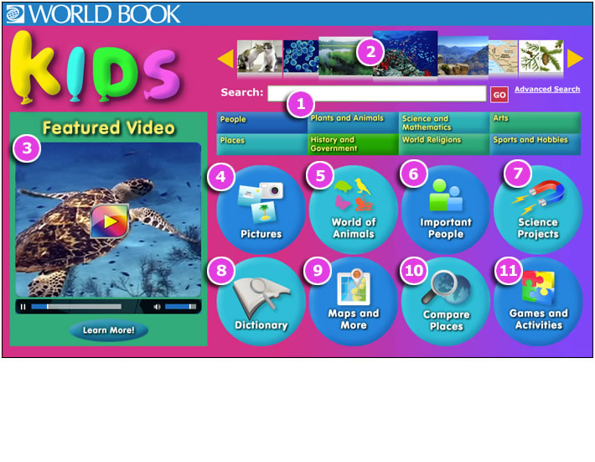and then click on the “GO” box, or just press “enter.”**

**OR**

1. **You can click on the “Plants and Animals,” rectangle below to search for your animal. Now type in your search animals name when the search box comes up on the next screen.**

**Now your article page should pop-up!**

**World Book Kids Article Example**

**Source: http://www.worldbookonline.com/training/kids/html/kids_2.htm**

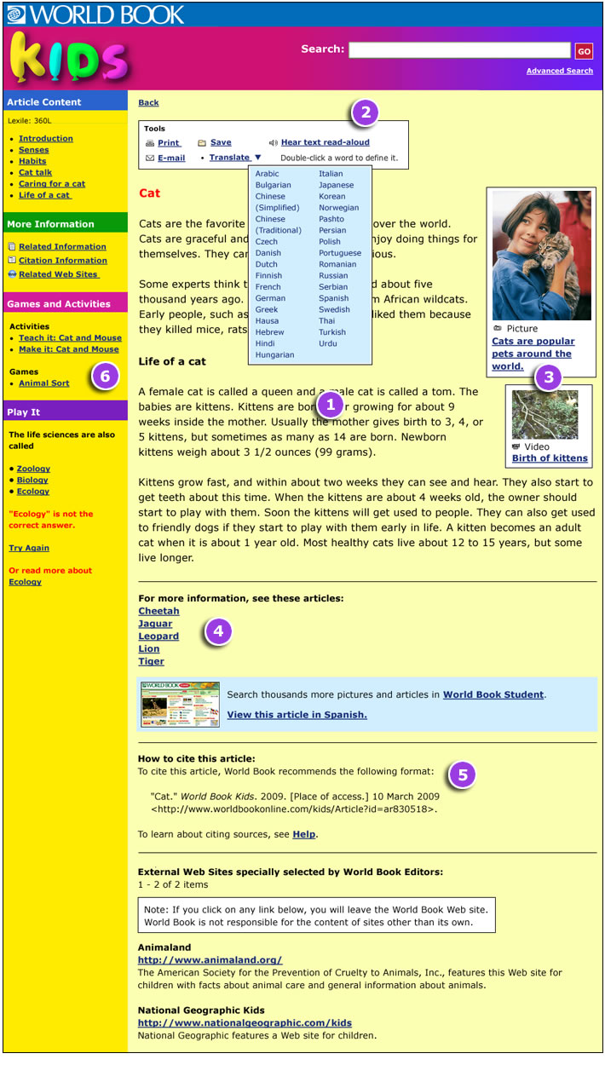

1. **Your article is on the page above.**
2. **The citation information is at the bottom of the article page.**
3. **If you want to watch a learning video you will find them here.**
4. **If you want to know the definition of a word in your article just double click on it, and a box will pop up that has the definition inside.**
5. **Look for words that appear alphabetically before and 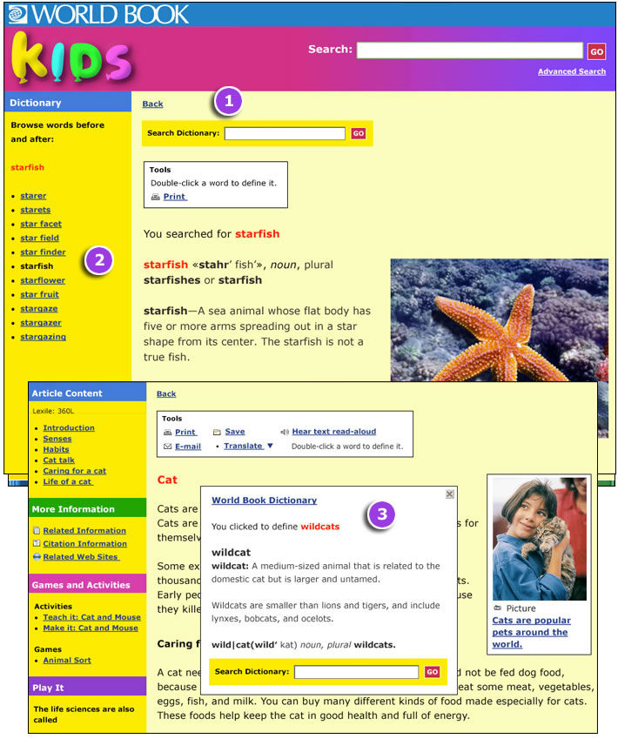after the selected word using the links in the left-hand index column.**

**World Book On-line’s ” World of Animals**

**This is a great way to research and compare animals.**

**1. Start by clicking on the “World of Animals,” circle.**

** Source:** [**http://www.worldbookonline.com/training/kids/html/kids_6.htm**](http://www.worldbookonline.com/training/kids/html/kids_6.htm)

**2. Look at many different animals by clicking on the white arrows.**

**3. When you see your animals picture click on it and when the next screen comes up you can read about your animal.**

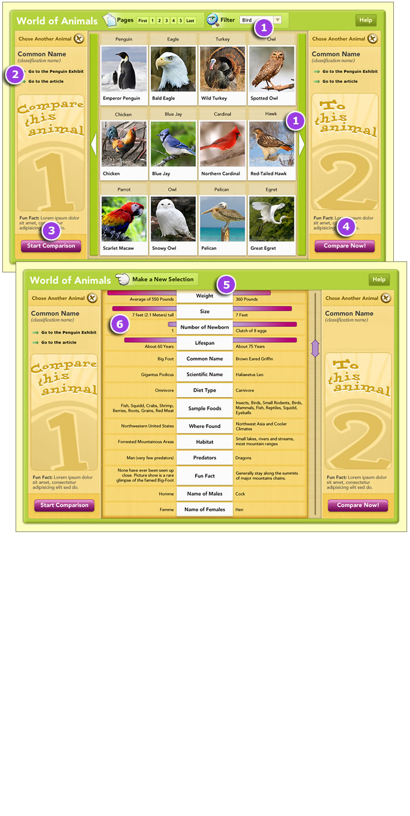**After choosing, and reading about, your first click on “Start Comparison” to select a second animal.**

**Source: http://www.worldbookonline.com/training/kids/html/kids_2.htm**

1. **Click on “Compare Now” to compare your animals side by side.**

**The World of Animals' comparison will come up. It displays animal facts and images side by side. Source:** [**http://www.worldbookonline.com/training/kids/html/kids_2.htm**](http://www.worldbookonline.com/training/kids/html/kids_2.htm)

**Using World Book Kids Dictionary**

**1. To go to the dictionary click on the circle with the word “Dictionary” in it. The circle is on the bottom right of the World Book Kids page.**

**2. Enter your word into the search box, and click on go.**

**3. A definition will come up.**

**Remember if you want to know the definition of a word when reading**

**an article just double-click on it.**



**When you double click on a word in your article to find the definition, (what it means), a box like the one above will pop up.**

**http://www.worldbookonline.com/training/kids/html/kids_4.htm**



**Click the x in the upper right to close the box.**

**Source: http://www.worldbookonline.com/training/kids/html/kids_6.htm**

**Name______________________________ Date___________________________**

C:\Users\Wapplega\AppData\Local\Microsoft\Windows\Temporary Internet Files\Content.IE5\EMCF94TQ\MC900301302[1].wmf

World Book Kids Animal Search Post-Test

2nd Grade

Using World Book on-line find information to answer these questions:

1. Find and write two sentences of information about an African elephant.

2. Find and write two sentences about Pandas from World Book Kids.

3. Find and write two interesting sentences of information about a Koala.

World Book Kids Research Rubric

|  |  |  |  |  |
| --- | --- | --- | --- | --- |
| CATEGORY | **Basic**  **4: Needs**  **Lots of Help** | **Proficient**  **3: Needs a Little**  **Help** | **Good**  **2: Needs Very**  **Little Help** | **Advanced**  **1: Needs No**  **Help** |
| **Computer Log On & Opening World Book Kids** | 1. Handle laptop with  care.  2. Push laptop start-  up button.  3. Log on to laptop. 4. Open World Book  Kids. | 1. Handle laptop with  care.  2. Push laptop start-  up button.  3. Log on to laptop. 4. Open World Book  Kids. | 1. Handle laptop with  care.  2. Push laptop start-  up button.  3. Log on to laptop. 4. Open World Book  Kids. | 1. Handle laptop with  care.  2. Push laptop start-  up button.  3. Log on to laptop. 4. Open World Book  Kids. |
| **Search World Book Kids for information/Two animals.** | 1. Locate the World  Book Search Box  on screen.  2. Use keyboard to  type in search  word into search  box. | 1. Locate the World  Book Search Box  on screen.  2. Use keyboard to  type in search  word into search  box. | 1. Locate the World  Book Search Box  on screen.  2. Use keyboard to  type in search  word into search  box. | 1. Locate the World  Book Search Box  on screen.  2. Use keyboard to  type in search  word into search  box. |
| **Read World Book Kids for Information** | 1. Read headings  and sub-  headings.  2. Reading for  information.  3. Copy complete  sentences. | 1. Read headings  and sub-  headings.  2. Reading for  information.  3. Copy complete  sentences. | 1. Read headings  and sub-  headings.  2. Reading for  information.  3. Copy complete  sentences. | 1. Read headings  and sub-  headings.  2. Reading for  information.  3. Copy complete  sentences. |
| **Locating and Copying Citations** | 1. Locate citation  information on the  WBKs screen.  2. Copy all of citation  from WBKs onto  information sheet. | 1. Locate citation  information on the  WBKs screen.  2. Copy all of citation  from WBKs onto  information sheet. | 1. Locate citation  information on the  WBKs screen.  2. Copy all of citation  from WBKs onto  information sheet. | 1. Locate citation  information on the  WBKs screen.  2. Copy all of citation  from WBKs onto  information sheet. |

Name_________________________________________

|  |  |  |
| --- | --- | --- |
| **Student Self-Assessment Check list:**  **Name______________________________________________________________** | | |
|  | 1.0 | Logging onto laptop & opening World Book Kids. |
|  | Always | Handle laptop with care. |
|  | 1.1 | Laptop startup sequence by pushing the power button. |
|  | 1.2 | Log on to laptop with user name and password. |
|  | 1.3 | Locate school home page and open. |
|  | 1.4 | Locate World Book icon on school home page and enter to open. |
|  | 2.0 | Use World Book Kids to search for information on 2 animals. |
|  | 2.1 | Locate the World Book Kids search box on the WBK page. |
|  | 2.2 | Type search word into WBKs search box and enter. |
|  | 3.0 | Read for information that is useful in your research in WBKs. |
|  | 3.1 | Read titles and sub-titles when reading for information. |
|  | 3.2 | Read the paragraphs looking for information. |
|  | 4.0 | Copy sentences onto your information sheets. |
|  | 4.1 | Copy the useful information/sentences onto your sheet. |
|  | 5.0 | Locate citation information-write it on your information sheet. |
|  | 5.1 | Locate citation information on the bottom left of screen. |
|  | 5.2 | Locate citation information and write it on your sheet. |

Student Research Information Sheet

Place your research sentences on the lines that are numbered, and your citation information, on the line below your sentence marked citation. You will find the citation on the lower left area on the World Book Kids Screen.

Sentence 1:__________________________________________

____________________________________________________

____________________________________________________

Citation: ____________________________________________

___________________________________________________

___________________________________________________

Sentence 2: __________________________________________

____________________________________________________

____________________________________________________

Citation_____________________________________________

____________________________________________________

____________________________________________________

Sentence 3: __________________________________________

____________________________________________________

____________________________________________________

Citation_____________________________________________

____________________________________________________

____________________________________________________

Sentence 4: __________________________________________

____________________________________________________

____________________________________________________

Citation_____________________________________________

____________________________________________________

____________________________________________________

Sentence 5: __________________________________________

____________________________________________________

____________________________________________________

Citation_____________________________________________

____________________________________________________

____________________________________________________

Sentence 6: __________________________________________

____________________________________________________

____________________________________________________

Citation_____________________________________________

____________________________________________________

____________________________________________________

|  |  |  |  |  |  |  |  |  |
| --- | --- | --- | --- | --- | --- | --- | --- | --- |
| **World Book Kids Research 21st Century Standards**  **Mrs. Applegate/ Mrs. Merrill 2nd Grade** | | | | | | | | |
| **21st Century**  **Standards** | | 1.1.1  Following and Inquiry based process… | 1.1.6  Read, view, & listen for information presented in any format… | 1.1.8  Demonstrate mastery of technology tools for assess. Inform. & inquiry. | 2.1.4  Use technology and other information tools to analyze & org. information. | 2.4.1  Determine how to act on information; accept/reject/or modify. | 3.1.6  Use information and technology ethically and responsibly. | 4.1.7  Use social networks &information tools to gather & share information. |
| 1 | K.A. |  |  |  |  |  |  |  |
| 2 | J.C. |  |  |  |  |  |  |  |
| 3 | C.D. |  |  |  |  |  |  |  |
| 4 | J.D. |  |  |  |  |  |  |  |
| 5 | S.D. |  |  |  |  |  |  |  |
| 6 | D.J. |  |  |  |  |  |  |  |
| 7 | B.L. |  |  |  |  |  |  |  |
| 8 | J.M. |  |  |  |  |  |  |  |
| 9 | K.N. |  |  |  |  |  |  |  |
| 10 | P.R. |  |  |  |  |  |  |  |
| 11 | K.S. |  |  |  |  |  |  |  |
| 12 | S.T. |  |  |  |  |  |  |  |
| 13 | A.T. |  |  |  |  |  |  |  |
| 14 | G.W. |  |  |  |  |  |  |  |

Language Arts: 2.1.6.e Retell and summarize the main idea from informational text.

Language Arts: 2.1.6 o Respond to text verbally, in writing and artistically.

Language Arts: 2.3.2 b Use information in order to complete a task (e.g., follow multi-step directions, responding to questions).

Language Arts: 2.4.1 a Use resources to answer guiding questions (e.g., print, electronic).

Science Standard: 2.3.1 a Students will investigate the Characteristics of living things.

|  |  |  |  |  |  |  |  |  |  |  |  |  |
| --- | --- | --- | --- | --- | --- | --- | --- | --- | --- | --- | --- | --- |
| **Steps to**  **Meet perform. objectives Checklist** | Stnt.  Name | 1.1  Laptop  start-up  sequence. | 1.2  Log on  to laptop. | 1.3  Locate  school  home-  page & open. | 1.4  Locate  WBK  icon &  open. | 2.1  Locate  WBK  Search  Box. | 2.2  Use keyboard  to type in search term. | 3.1  Read headings & sub-  Headings. | 3.2  Read for  relevant  facts. | 4.1  Copy full sentences onto information worksheet. | 5.1  Locate citation inform. | 5.2  Type  entire  citation for each sentence used. |
| 1 | K.A. |  |  |  |  |  |  |  |  |  |  |  |
| 2 | J.C. |  |  |  |  |  |  |  |  |  |  |  |
| 3 | C.D. |  |  |  |  |  |  |  |  |  |  |  |
| 4 | J.D. |  |  |  |  |  |  |  |  |  |  |  |
| 5 | S.G. |  |  |  |  |  |  |  |  |  |  |  |
| 6 | D.J. |  |  |  |  |  |  |  |  |  |  |  |
| 7 | B.L. |  |  |  |  |  |  |  |  |  |  |  |
| 8 | J.M. |  |  |  |  |  |  |  |  |  |  |  |
| 9 | K.N. |  |  |  |  |  |  |  |  |  |  |  |
| 10 | P.R. |  |  |  |  |  |  |  |  |  |  |  |
| 11 | K.S. |  |  |  |  |  |  |  |  |  |  |  |
| 12 | S.T. |  |  |  |  |  |  |  |  |  |  |  |
| 13 | A.T. |  |  |  |  |  |  |  |  |  |  |  |