Songs that Add Rhyme to your Routine
July 24, 2012 by thisreadingmama 9 Comments
Raffi’s “You Brush Your Teeth” Song (a classic!)

Brush, Brush, Brush Your Teeth
(tune: Row, Row, Row Your Boat)

Brush, brush, brush your teeth
Brush them every day
Brush, brush, brush your teeth
Keep cavities away.

3. GETTING DRESSED
This is the Way
(tune: Mulberry Bush)

This is the way we put on our shirt,
put on our shirt,
put on our shirt,
This is the way we put on our shirt
So early in the morning.
(verses: put on our pants, shorts, hat, shoes, etc.)

4. WASHING HANDS
Wash Your Hands
(tune: Clap Your Hands)

Wash, wash, wash your hands
Scrub your hands together
Wash, wash, wash your hands
Scrub your hands together
Scrub a little faster now
Scrub along with me
Scrub a little slower now
Scrub along with me.

8. CLEANING UP
Clean Up Song

Clean up, clean up
Everybody, everywhere
Clean up, clean up
Everybody do your share.
(I couldn’t find the link, but Barney made this one popular!)

A Helper I Will Be
(tune: The Farmer in the Dell)

A helper I will be,
A helper I will be.
There’s work to do,
There’s work to do
A helper I will be.

9. BATH TIME
Head, Shoulders, Knees and Toes

Scrub-a Dub, Dub
(tune: Skip to My Lou)

Scrub-a dub, dub
In the tub
Scrub-a dub, dub
In the tub
Scrub-a dub, dub
In the tub
Get clean in the tub.
Teeth Brushing Song (Sung to Mulberry Bush tune)
This is the way we brush our teeth, brush our teeth, brush our teeth.
This is the way we brush our teeth, so early in the morning!
(Or for night-time, substitute ‘so early in the morning’ for ‘before we go to bed’)

Why do kids need nursery rhymes? (10 reasons!)
by Anna G Measured Moms Web Site August 17, 2014
Nursery rhymes. These little poems and songs have been around for centuries. Despite all the changes the world has seen in last 500 years, nursery rhymes are here to stay. Today I’m sharing ten reasons why your kids need to know them. If you have a child who’s past preschool, stay tuned. Nursery rhymes and other popular rhymes and songs are for kids of all ages!

Why do kids need nursery rhymes?

1. Nursery rhymes are the perfect first stories.
I’ve found it difficult reading aloud to babies who want to grab and mouth everything. That’s why I like to keep short rhyming board books on hand when we have a baby in the house. The bouncy rhythm catches their attention, and the short length means I might be able to finish a rhyme before little hands grab the book.
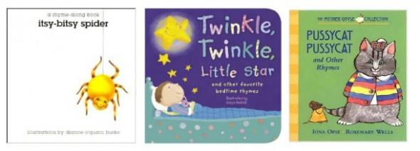
My favorites are nursery rhyme board books with one rhyme (or just a few) per book, like the Rhyme Along Board Book series by Dianne O’Quinn Burke (find them at yard sales!) and the newer Padded Nursery Rhyme Board Books by Sonja Rescek. Most of all I recommend the wonderful My Very First Mother Goose board book series, illustrated by Rosemary Wells.

Toddlers are ready to listen to a story without grabbing the book or tearing the pages, but they might not be ready for a long story. Books of nursery rhymes are a great transition to longer books because you can read as many or as few rhymes as your toddler prefers. My kids have enjoyed the hand-stitched illustrations in Kate Toms’ Nursery Rhymes. We also like Pocketful of Posies: A Treasury of Nursery Rhymes. Our favorite has been the completed My Big Sticker Book of Nursery Rhymes. (I recently bought a new one to read to our baby, since our old copy has been loved to pieces!)

2. Nursery rhymes can boost early language development.
So does that mean if you read nursery rhymes beginning from the first week of life your child will be an early talker? Not necessarily. I read stacks of books to our oldest every day, but she didn’t utter a word until she was over 2 1/2. When she finally began to speak, however, we heard pieces of all the nursery rhymes I’d been reading to her since she was a baby.

3. Knowing nursery rhymes can build social skills and promote a sense of community.
When I taught in a classroom, my favorite part of the day was when I read from our current read aloud book. Even those years when I had a class of kids who couldn’t quite get along, we all came together for the story. Children bond over a shared story, and when you have a classroom (or houseful) or children who know the same rhymes, they have fun reciting and singing together.

4. Loving nursery rhymes opens the door to a love of all books.
I remember sitting on the couch with our oldest when she was nine months old. As she squirmed and grabbed for the pages, I lamented to my husband, “I just wish she would love listening to books!” Just a few months later, she began paging through books on her own. Now seven years old, she’s a total bookworm. Those early rhymes gave her a love for books which she hasn’t lost!

5. Kids who know nursery rhymes are equipped to be better readers.
Listening to nursery rhymes strengthens kids’ ability to hear the sounds in words. For six reasons that rhyming is important, check out this post. And to find a list of five pre-reading skills you can teach through nursery rhymes, visit Pre-K Pages.

6. Listening to nursery rhymes builds vocabulary.
The more stories and rhymes kids hear, the larger their vocabulary. A strong vocabulary improves listening comprehension, social conversations, writing, and more! (Be sure to check out five tips for building your child’s vocabulary.)

7. A love for nursery rhymes opens the door to creativity.
Act out rhymes, create nursery rhyme crafts, illustrate favorite rhymes, and write your own. Plus, listening to rhymes without pictures lets your child create mental images in his head. (This ability will come in handy when he starts reading chapter books!)
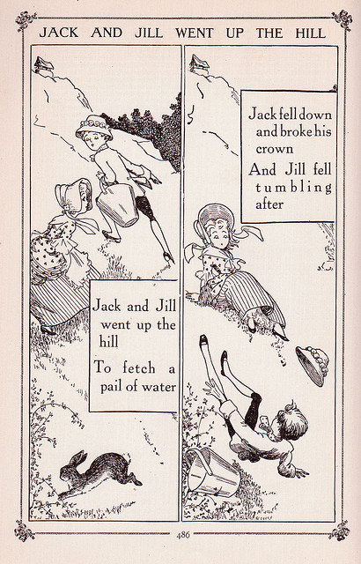

8. Nursery rhymes connect us to the past.
Don’t you love reading a favorite picture book from your childhood to your own kids? When you share nursery rhymes that you knew as a child, you can have that same joy.
Besides connecting our children to our own childhood, nursery rhymes can provide a quick history lesson. When we read an illustrated version of “Jack and Jill,” we teach our preschoolers that there was life before indoor plumbing. “Jack Jumped over a Candlestick” gives a glimpse into a world without electricity.

9. Singing nursery rhymes can improve fine motor skills and coordination.

When children do finger plays (think “Itsy Bitsy Spider”) and act out other rhymes (like “Jack Jumped Over a Candlestick”), they can even improve muscle strength! (The above picture is part of a set of free finger puppets I’ll be sharing beginning tomorrow… stay tuned!)

10. Nursery rhymes are just plain fun.
Silly rhymes and nonsensical verse are appealing to kids. That’s why these rhymes are still popular after 500 years!
P.S. Shortly after I published this post, Heidisongs released these singable nursery rhymes! Listen to them in the car and your kids will know their rhymes in no time!)
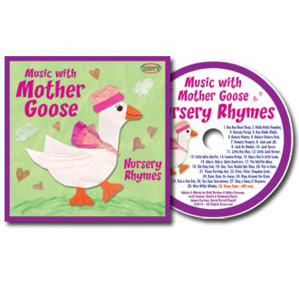Did You Know?
One of the key predictors for early success in reading is how well kids know their nursery rhymes.

